**Santa Claus**

Let j: 0, …, n-1 be the child index $d[j] denotes the number of toys the child deserve$

Let i: 0, …, m-1 be the toy index $\text{c}\left[\text{i}\right] \text{denotes} \text{the} \text{count} \text{of} \text{this} \text{item,} \text{before} \text{allocation}$

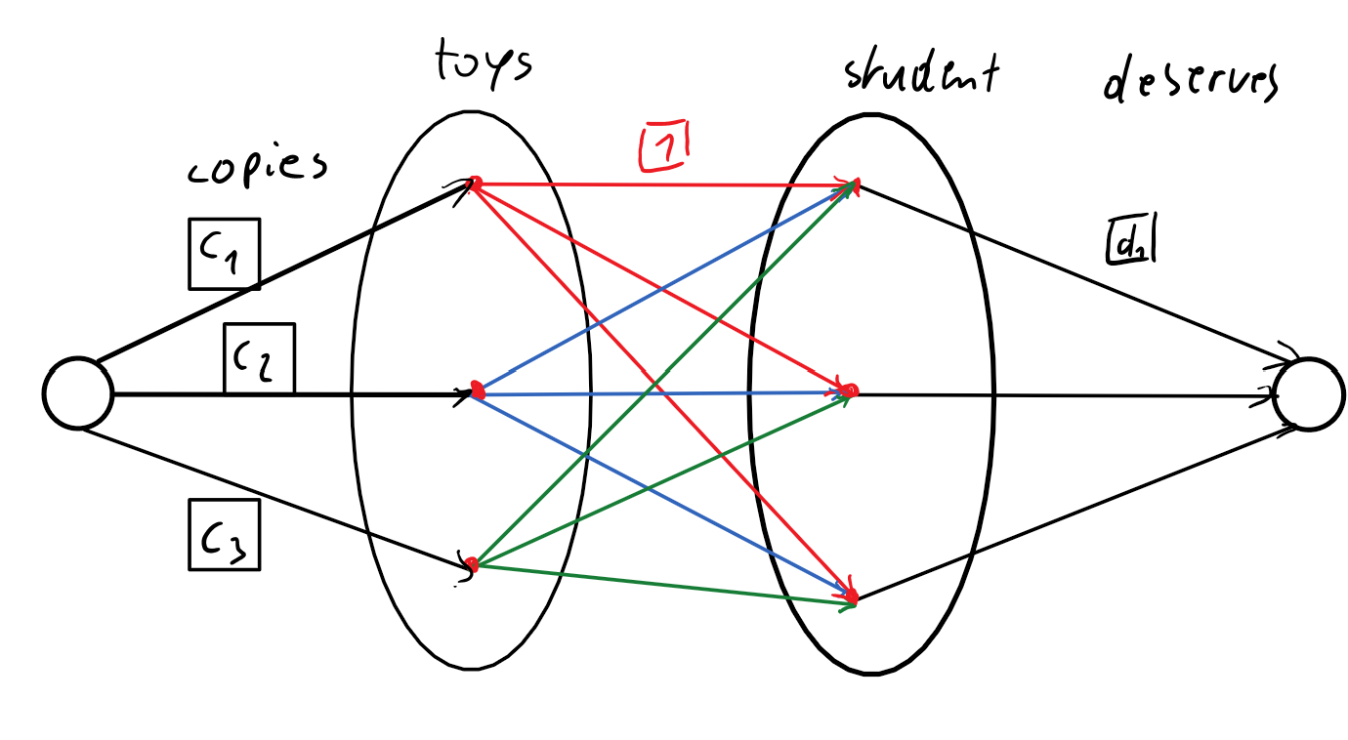

In order to solve the problem, we need to calculate the Max-Flow of the network. S is the Santa. T needs to be exactly the capacity of all student wishes. $T=val\left(f\right)=\sum_{i}{d\left[i\right]}$

Algorithm idea:

Create Network:

1. Create vertex Santa
2. Create vertex T
3. Create vertices children (n)
4. Create vertices toys (m)
5. Connect Santa to toys: (cap = c[i])
6. Interconnect all toys and children (cap = 1)
7. Connect all Children to T: (cap = d[i])
8. Calc Max Flow
9. If flow = Sum…: yes, else: no

Vertex indices:

|  |  |  |  |  |
| --- | --- | --- | --- | --- |
|  | S | T | Toys | Children |
| Index | 0 | 1 | 2 … 2 + m -1 | 2 + m … 2 + m + n -1 |
|  |  |  |  |  |